Urgent Demonstration Project for Next-Generation Bi-directional Communication Output Control

Inverter with power control function
(less than 6 6 k V)
Schedule Information Distribution System Transmission Specification (Power Plant)

2015.08.25 Establishment
2015.12.10 Revision

KYUSHU ELECTRIC POWER CO., INC

Prohibition of Use, Reproduction, and Disclosure Other Than Purpose

Change Further Notes Record REVISIONS
Change symbol REV. MARK  Change Issue Date REV. ISSU ED | Paged PAGE | CHANGED PLACE AND CONTENTS
0 |  | First edition published
 | 6 | Table 2 . 1 Add Cipher Suite
 | 15 | 3 . 3 Change the description of the header section from the number of records to the number of data
1 | 16  17 | 3 . 3 . 1 "0 00 0" is added to the explanation of "Control date and time" of the transmission field.  3 . 3 . 2 "0 00 0" is added to the explanation of "Control date and time" of the transmission field.
15.10.09 | 21  22 | 4 . 2 . 2 Changes the output of error messages.  4 . 2 . 3 Add (Re-assign page number thereafter)
 | 7 | Table 2 . 2 Describe URL
 | 8 | Figure 2. 2 Changing Examples of Requests to U R L
 | 20 | Table 4 . 1 Change HT T P status code " 4 x x" to "Not required" for retry.
2 | 21 | 4 . 2 . 1 Added a description of the file name of the error file.
 | 21 | 4 . 2 . 2 Changed supplementary explanation of error file.
15.10.23 | 22 | Table 4 . 4 Delete error messages that you do not want to deliver
 | 23 | Table 5 . 2 Describe FQDN
 | 9 | Transmit example response file (Figure 2). 3) and the error file (Figure 2. To 4) and the contents of the description
 |  | Review
 | 13 | 3 . 3 With a file format of 3. 2 Change to file format (page numbering again)
 |  | Figure 3. 2 Figure 3 shows an example of the transmission file format. 1 Change to transmission file format example
 |  | Figure 3. 1 The format of the data section is "*3. Changed to "See Chapter 4"
 | 14 | 3 . 2 With binary conversion rules 3. 3 Change to binary conversion rule
3 |  | Figure 3. 1 Example of binarization (data part) is shown in Figure 3. 2 Changed to binary example  Figure 3. The example of binary conversion of the header part is described in 2.
15.11.06 | 15 | Figure 3. Change the number of data items in 2 to the number of output control rate data items.  3 . 4 Added data part format (Chapters numbering again)
 |  | 3 . 4 . 1 Change the explanation of the transmission item "Control date and hour" to "DD hh mm is "0 10 00"...
 |  | 3 . 4 . 1 Change the transmission item name to "Number of output control rate data"
 | 16 | 3 . 4 . 2 Change the explanation of the transmission item "Control date and hour" to "DD hh mm is "0 10 00"...
 |  | 3 . 4 . 2 Change the transmission item name to "Number of output control rate data"
 | 17 | 3 . 4 . 3 Change the transmission item name to "Number of output control rate data"
4 | 9 | Figure 2. 3 Removed " ch ar se t= UT F 8 " from HT T P response header and HT T P response body. Modified fi le na m e.  Figure 2. 4 Removed " ch ar se t= UT F 8 " from HT T P response header  Figure 2. 4 Changing HT T P response body to "Co nt en t-Ty pe : tex t/p la in"
15.11.13 | 10
5  15.12.10 | 2 0 | Add variable length to error message data type

Table of Contents
1 SUMMARY 3
1.1 Purpose 3
1.2 Range of this document 3
1.3 Definition of Terms 4
2 Data linkage. 6
2.1 Communication Overview 6
2.2 Outline of the linkage 7
2.3 Request timing 12
2.3.1 Fixed schedule (annual) and fixed schedule (monthly) requirements 12
2.3.2 Requesting an Update Schedule 12
2.3.3 Request for ID registration confirmation 12
3 Transmission file 13
3.1 File Formats and Naming Conventions 13
3.2 File formats 13
3.3 Binary conversion rules 14
3.4 Format of the data section 15
3.4.1 Fixed schedule (annual) 15
3.4.2 Fixed schedule (monthly) 16
3.4.3 Update schedule 17
3.4.4 ID registration confirmation result 18
4 Linkage error. 19
4.1 Response error 19
4.2 Application error 20
4.2.1 File Formats and Naming Conventions 20
4.2.2 File formats 20
4.2.3 Error Message 21
5 Time synchronization. 22
5.1 Overview of time synchronization 22
5.2 Time Synchronization Protocol 22
5.3 Time Synchronization Timing 23

Figure 1.1 Scope of this Manual 3
Figure 1.2 Power Station ID 4
Figure 2.1 Overview of Communications 6
Figure 2.2 Example request 8
Figure 2.3 Example response (transmission file) 9
Figure 2.4 Example response (error file) 10
Figure 3.1 Format configuration of transmission file 13
Figure 3.2 Example of binarization 14
Figure 5.1 Overview of Time Synchronization 22

Table 2.1 Overview of communication 6
Table 2.2 Request URL 7
Table 2.3 Request parameters 7
Table 2.4 Schedule categories 7
Table 2.5 Outline of transmission files 10
Table 2.6 Schedule categories and transmission files 11
Table 2.7 Request timing for fixed schedules 12
Table 4. 1 HTTP status codes 19
Table 4.2 Retry timing when a response error occurs 19
Table 4.3 Error code system 21
Table 4.4 List of error messages 21
Table 5.1 Communication Specifications for Time Synchronization 22
Table 5. 2 NTP Server Settings 22
Table 5.3 Time Synchronization Timing 23
Table 5.4 Periodic update timing 23

1 SUMMARY

1.1 Purpose
This document describes how to link schedule information distribution systems, such as schedule information, to power plants.

1.2 Range of this document
The scope of this document is shown in Figure 1.1.

Schedule information distribution system

Distributor

Power plant

: Scope of this document

Power plant
Figure 1.1 Scope of this Manual

1.3 Definition of Terms
Major terms in this document are defined below.

- Power plant ID
ID consisting of 26 digits of the receiving point identification number (22 digits) + branch number (3 digits) + checksum (1 digit). Figure 1.2 shows the configuration of the high-and low-pressure power plant ID.

 | High and low pressure division |  | Each power-specific code |  | Branch number |  | Checksum
 | (1 digit) |  | (19 digits) |  | (3 digits) |  | (1 digit)
+ | ▲ | + | ■■■・・・■■■ | + | ○○○ | + | □

●●
Power Transmission and Distribution Operator Code
(2 digits)

Equivalent to receiving point identification number (22 digits)

Figure 1.2 Power Station ID

- Checksum
A checksum shall be provided for the plant ID and schedule in order to detect input errors and prevent data tampering.
The following shows how to calculate the checksum for each data item.

(a) Power plant ID
The checksum of the plant ID shall be the last digit of the solution obtained by the following formula.
(1st digit × 1) + (3rd digit × 5) + (5th digit × 9) + (6th digit × 1) + (7th digit × 5) + (9th digit × 9) + (11th digit × 3) + (13th digit × 5) + (14th digit × 9) + (16th digit × 1) + (17th digit × 3) + (18th digit × 5) + (9th digit × 7) + (20th digit × 9))
(21st digit × 1) + (22nd digit × 3) + (23rd digit × 5) + (24th digit × 7) + (25th digit × 9)

Example) When power plant ID (excluding checksum part) is 1234567890123456789012345 (1 × 1) + (2 × 3) + (3 × 5) + (4 × 7) + (5 × 9) +
(6×1)+(7×3)+(8×5)+(9×7)+(0×9)+
(1×1)+(2×3)+(3×5)+(4×7)+(5×9)+
(6×1)+(7×3)+(8×5)+(9×7)+(0×9)+
(1×1)+(2×3)+(3×5)+(4×7)+(5×9)=545
The checksum is the last digit "5" of the solution.

(b) Fixed schedule and update schedule
The checksum of the fixed schedule and the update schedule shall be the last two digits of the solution obtained by the following formula.
(Output control rate 1 + Output control rate 2 + Output control rate 3...)
Divided by (month, month, and hour of control + day, month, and hour of control)

Example: Output Control Rate 1:100 Output control ratio 2:40 Output Control Rate 3:28 Date/Time of Control: 201503271005

(100+40+28) ÷(3+27) = 5 Remaining 18 checksum is the remainder "18".

2 Data linkage

2.1 Communication Overview
The communication between the plant and the scheduling information delivery system uses HTTPS(Hyper Text Transfer Protocol Secure) to communicate via secure communication provided by Transport Layer Security (TLS) protocol (see Fig. 2.1). This secure communication prevents eavesdropping, tampering, and spoofing of data.
In order to perform this HTTPS communication, a root certificate is allocated to the plant (client), and a server certificate issued by a certificate authority is allocated to the scheduling information distribution system (server). These certificates are used to authenticate HTTPS communication.
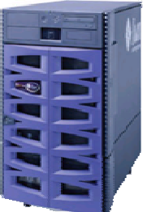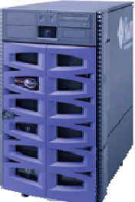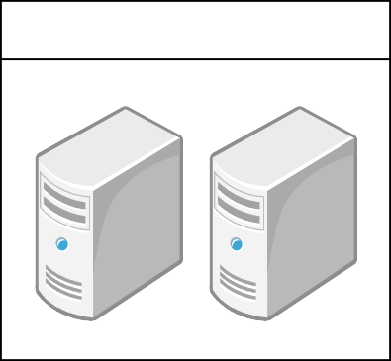Table 2.1 shows the outline of HTTPS communication.
Schedule information distribution system
Power plant
①
HTTPS-REQUEST

Figure 2.1 Overview of Communications
②

HTTPS-RESPONSE

Table 2.1 Communication Summary

Communication method | HTTPS(Hyper Text Transfer Protocol Secure)
Communications protocols | TLS(Transport Layer Security)1.2
Communications protocols | HTTP(Hypertext Transfer Protocol)1.1
Cipher suite | TLS_RSA_WITH_AES_128_CBC_SHA256 TLS_RSA_WITH_AES_256_CBC_SHA256

2.2 Outline of the linkage

- Requirements from power plants (HTTPS-REQUEST)
The plant requests files such as schedules to the scheduling information distribution system for the URLs and ports shown in Table 2.2.
Table 2.2 Request URL

Scheduling information distribution server | URL | https://re-ene.kyuden.co.jp/scheduleSend/
Scheduling information distribution server | Port | 443

In addition, requests for files are made to the scheduling information distribution system using POST(METHOD attributes). Table 2.3 shows the parameters when requesting a file.
Table 2.3 Request parameters

Logical name | Physical name | Data type | Description
Power plant ID | Power_plant_id | 26 digits of the string | -
MAC address | Mac_address | 12-digit string | Only hexadecimal values excluding the conjunctions ":", "-", etc. shall be used, and alphabetic characters shall be uppercase.  e.g., "01-23-89-ab-cd-ef"  「012389ABCDEF」
Schedule classification | Schedule_kbn | 4-digit string | See Table 2.4

Table 2.4 shows the schedule categories for the request parameters.

Table 2.4 Schedule categories

Category value | Description
999_ | Fixed schedule (annual) | The last digit <_> is an item in the update schedule file.  Specify the fixed schedule update flag,  Specifies which fixed schedule (annual) you want to acquire.
YYMM | For the 20YY MM month  Fixed schedule (monthly) | When acquiring a fixed schedule (month and year), specify the year and month.
0000 | Update schedule | -
8888 | For ID registration confirmation | Confirm whether or not the power station ID is registered.

Figure 2.2 shows an example of the minimum requests required to request a file.
POST /scheduleSend/ HTTP/1.1
Host: re-ene.kyuden.co.jp Connection: close Content-Length: 107
Content-type: application/x-www-form-urlencoded
・
・
・
(Empty lines)
Power_plant_id=23498213471000000000000017&mac_address=012389ABCDEF
&schedule_kbn=0000

HTTP request

HTTP header

HTTP body

Figure 2.2 Example request
POST

Keep-Alive Off

See Table 2.3

- Reply from Scheduled Information Delivery System (HTTPS-RESPONSE)
The schedule information distribution system responds to the power plant with the file based on the schedule segment requested by the power plant.
A response to a file returns a multipart response (Content-Type: multipart/mixed).
Figure 2.3 shows an example response (transmission file) and Figure 2.4 shows an example response (error file).

HTTP Response Status

HTTP response headers

HTTP response body

Figure 2.3 Example response (transmission file)
HTTP/1.1 200 OK
Content-Type: multipart/mixed;boundary="BOUNDARY" Content-Length: 19970
Connection: close
・
・
・
(Empty lines)
-- BOUNDARY
Content-Length: 19729
Content-Type: application/octet-stream
Content-Disposition: attachment; filename=201_9990_123456789012345 67890123456_20150831123059.data
・
・
・
(Empty lines)
Transmission file (binary file) ※ See chapter 3
-- BOUNDARY--

Delimiter

Download file

Delimiter

HTTP Response Status

HTTP response headers

HTTP response body

Figure 2.4 Example response (error file)
HTTP/1.1 200 OK
Content-Type: multipart/mixed;boundary="BOUNDARY" Content-Length: 262
Connection: close
・
・
・
(Empty lines)
-- BOUNDARY
Content-Length: 239
Content-Type: text/plain; charset=UTF-8
Content-Disposition: attachment; filename=ERR_0000_123456789012345 67890123456_20150831123059.data
・
・
・
(Empty lines)
Error file (text file) ※ See chapter 4.2
-- BOUNDARY--

Delimiter

Download file

Delimiter

A summary of the file is shown in Table 2.5. A description of the file format is given in Section 3.4. Table 2.5 Outline of transmission files
Transmission file | Description | Format  №
Fixed schedule (annual) | Annual fixed schedule information | 201
Fixed schedule (monthly) | Fixed schedule information for the month | 202
Update schedule | Update schedule information | 203
ID registration confirmation result | Information on the registration confirmation result of the power station ID | 301

The transmission file responsive to the plant for the requested schedule segment is shown in Table 2.6.

Table 2.6 Schedule categories and transmission files

Transmission file  Schedule classification |  | Fixed schedule (annual) | Fixed schedule (monthly) | Update schedule | ID registration confirmation result
 |  | 201 | 202 | 203 | 301
999_ | Fixed schedule (annual) | ○
YYMM | Fixed schedule (monthly) |  | ○
0000 | Update schedule |  |  | ○
8888 | Confirmation of ID registration |  |  |  | ○

2.3 Request timing

2.3.1 Fixed schedule (annual) and fixed schedule (monthly) requirements
When the Fixed Schedule Update Flag item in the update schedule file is changed, a request is made to the schedule information delivery system for the fixed schedule (yearly) or fixed schedule (monthly) delivery.
The request to the schedule information distribution system is made in a time zone in which the request can be made to prevent the request from the distribution business operator or the power station from concentrating, and the load distribution is attempted. Therefore, when a request is made from a power station, the request shall be made in the time zone shown in Table 2.7 according to the value of the checksum at the end of the power station ID.
Table 2.7 Request timing for fixed schedules

Checksum | Required time zone
0 | 21:10:00 ～ 21:29:59
1 | 21:40:00 ～ 21:59:59
2 | 22:10:00 ～ 22:29:59
3 | 22:40:00 ～ 22:59:59
4 | 23:10:00 ～ 23:29:59
5 | 23:40:00 ～ 23:59:59
6 | 0:10:00 ～ 0:29:59
7 | 0:40:00 ～ 0:59:59
8 | 1:10:00 ～ 1:29:59
9 | 1:40:00 ～ 1:59:59

2.3.2 Requesting an Update Schedule
Requests for update schedules from the plant shall be made at the time specified in the item "Next Access Date" of the update schedule file.

2.3.3 Request for ID registration confirmation
For the ID registration confirmation, after receiving the power station ID or replacing the equipment, the power station makes a request as necessary.

3 Transmission file
The format of the transmission file that the scheduling information distribution system responds to requests from the plant is shown below.

3.1 File Formats and Naming Conventions
The format and file name of the file transmitted from the schedule information distribution system shall be as follows.
① Format: Binary file
② Character code :UTF-8
③ Byte Order: Network Byte Order
④ Filename: data of CCC_FFFF_XXXXXXXXXXXXXXXXXXXXXXXXXX_YYYYMMDDhhmmss.
CCC: Format No (without zero suppression) ※ Refer to Table 2.5 FFFF: Requested scheduling classification (without zero suppression) * Refer to Table 2.4 XXXXXXXXXXXXXXXXXXXXXXXXXX: Power plant ID
YYYY : MM of the date and time of file generation in the schedule information delivery system : 〃 Month
DD : 〃 Day
Hh : 〃 Time
Mm : 〃 Minutes
Ss : 〃 Second

e.g. Fixed schedule for request from plant ID 12345678901234567890123456
(Yearly) (Formatted No201) When a response file is generated at 10:5:20 on May 5, 2015
201_9990_12345678901234567890123456_20150505100520.data

3.2 File formats
The transmission file consists of a header section and a data section. The header portion outputs the number of data of the data portion, the data portion repeatedly outputs each format by the number of data of the header portion.
Figure 3.1 shows the format structure of the transmission file.
Data section
(Repeat same format)
Header (6byte)

Number of data
Format No:XXX | Format No:XXX | Format No:XXX

Repeat the number of data items in the header section.
(See Chapter 3.4)

Figure 3.1 Format configuration of transmission file

3.3 Binary conversion rules
The schedule information distribution system creates a binary format file as a transmission file to respond according to the following rules.

  - Binary conversion of the header section and data section is performed in hexadecimal (1 byte) in 1-digit units. However, the output control rate is binary converted in hexadecimal (1 byte) for each data.
  - The basic fixed length shall be defined. However, the portion of the output control rate is a variable length, and the number of bytes is represented by the number of output control rate data.

Figure 3.2 shows an example of a binary update schedule.

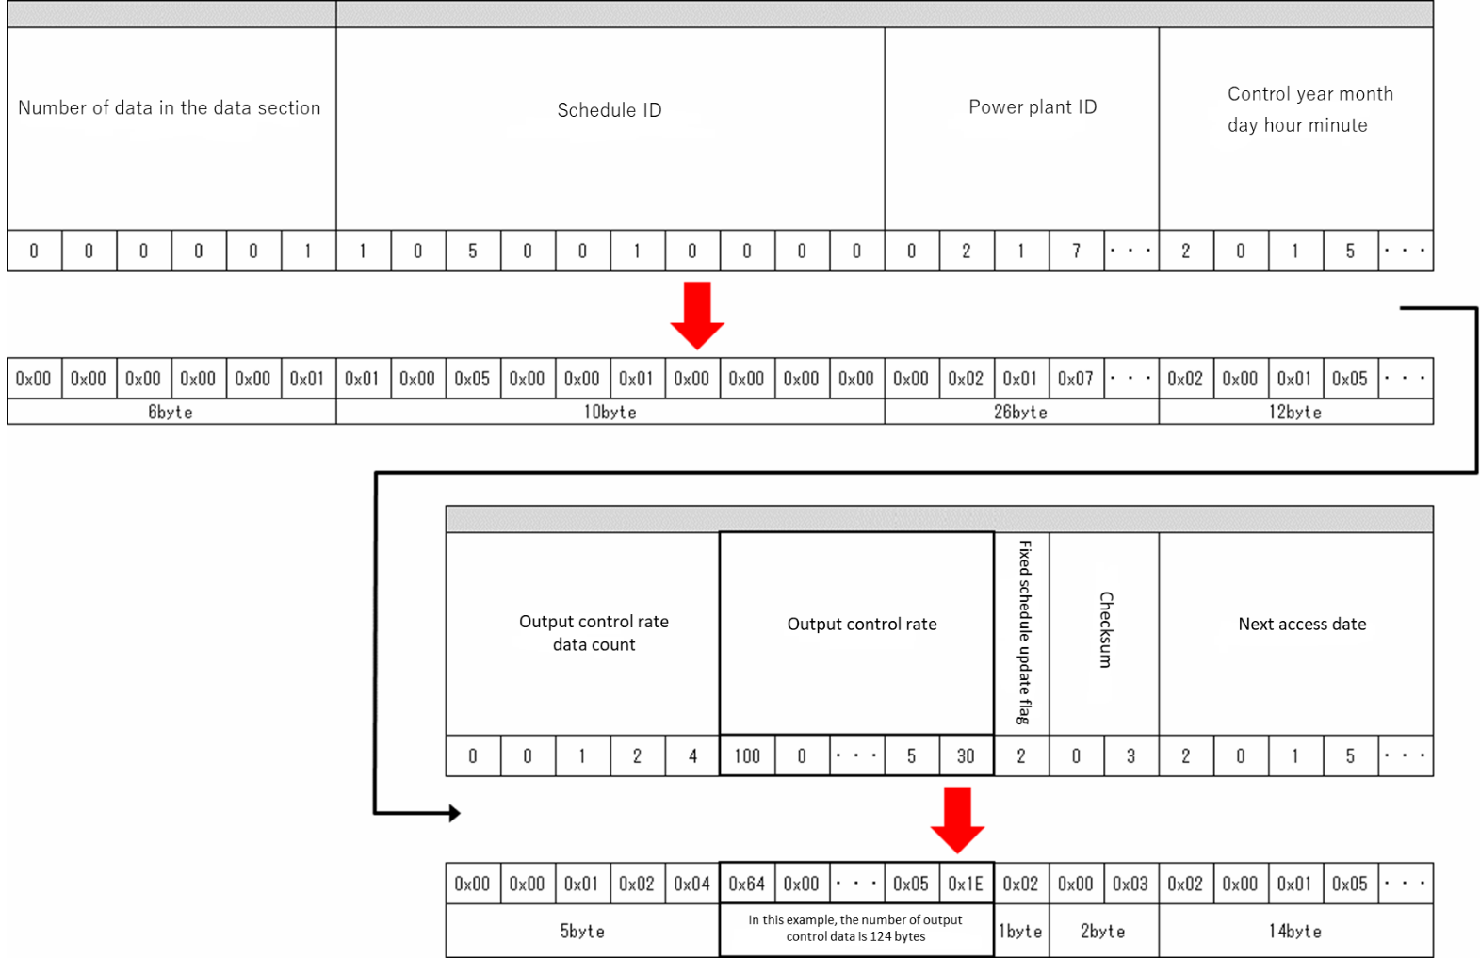

Figure 3.2 Example of binarization

3.4 Format of the data section
The format of the data portion of the transmission file is shown below.

3.4.1 Fixed schedule (annual)
This property indicates the fixed schedule (annual) format.

[Format No. 201]
Item | In bytes | Explanation
Schedule ID | 10Byte | -
Power plant ID | 26Byte | -
Date and time of control | 12Byte | Sets the year, month, day, hour, and minute of the first schedule frame. Formatting: YYYYMMDDhhmm  ※ DDhhmm is "010000"
Number of output control rate data | 5Byte | Number of output control rate data (maximum 1488)  ※ Up to 1488 for the maximum number of days of the relevant month separated by 30 minutes  (24 hours/0.5 hours × 31 days)
Output control rate | 1Byte x number of data | Unit: %  Repeat for the number of output control rate data (maximum 1488)
Checksum | 2Byte | -

(Supplementary explanations)
The fixed schedule of the requested power plant for 13 months is output. The image of the file at this time is shown below.

At the power plant that made the request
Fixed schedule of 13 months
Schedule ID... checksum | ・・・ | Schedule ID... checksum

Schedule ID | Power plant ID | Date and time of control | Number of output control rate data | Output control rate | Checksum

Output control rate 1 | Output control rate 2 | ・・・ | Output control rate N

N: Number of output control rate data

3.4.2 Fixed schedule (monthly)
This property indicates the format of a fixed schedule (monthly).

[Format No. 202]
Item | In bytes | Explanation
Schedule ID | 10Byte | -
Power plant ID | 26Byte | -
Date and time of control | 12Byte | Sets the year, month, day, hour, and minute of the first schedule frame. Formatting: YYYYMMDDhhmm  ※ DDhhmm is "010000"
Number of output control rate data | 5Byte | Number of output control rate data (maximum 1488)  ※ Up to 1488 for the maximum number of days of the relevant month separated by 30 minutes  (24 hours/0.5 hours × 31 days)
Output control rate | 1Byte x number of data | Unit: %  Repeat for the number of output control rate data (maximum 1488)
Checksum | 2Byte | -

(Supplementary explanations)
Output information for one month of the fixed schedule of the power plant that made the request. The image of the file at this time is shown below.

One month's fixed schedule for the power plant that made the request

Schedule ID... checksum
Schedule ID | Power plant ID | Date and time of control | Number of output control rate data | Output control rate | Checksum

Output control rate 1 | Output control rate 2 | ・・・ | Output control rate N

N: Number of output control rate data

3.4.3 Update schedule
Indicates the format of the update schedule.

[Format No. 203]
Item | In bytes | Explanation
Schedule ID | 10Byte | -
Power plant ID | 26Byte | -
Date and time of control | 12Byte | Sets the year, month, day, hour, and minute of the first schedule frame.  Formatting: YYYYMMDDhhmm
Number of output control rate data | 5Byte | Number of output control rate data (maximum 336)  ※ A maximum of 336 is the maximum number of update days separated by 30 minutes.  (24 hours/0.5 hours × 7 days)
Output control rate | 1Byte x number of data | Unit: %  Repeat for the number of output control rate data (maximum 336)
Fixed Schedule Update Flag | 1Byte | Count up when fixed schedule is updated, and new fixed schedule can be acquired.  Flag that notifies you of the fact.
Checksum | 2Byte | -
Next access date and time | 14Byte | Set the next delivery date and time.  Formatting: YYYYMMDDhhmmss

(Supplementary explanations)
The information on the update schedule of the requested power station is output for up to seven days. The image of the file at this time is shown below.

Schedule for renewal of the plant that made the request
Schedule ID... Next access date and time

Schedule ID | Power plant ID | Date and time of control | Output control rate  Number of data | Output  Control rate | Fixed schedule  Update flag | Checksum | Next time  Access date and time

Output control rate 1 | Output control rate 2 | ・・・ | Output control rate N

N: Number of output control rate data

3.4.4 ID registration confirmation result
The format of the registration confirmation result of the power station is shown.

[Format No. 301]
Item | In bytes | Explanation
Power plant ID | 26Byte | -
Results of registration confirmation | 1Byte | 0: ID registered  1: ID not registered

(Supplementary explanations)
One registration confirmation result of the requested power station is output. You respond with a single file.
The image of the file at this time is shown below.
Results of registration confirmation
Power plant ID

4 Linkage error
In addition to the mere communication error between the power station and the schedule information distribution system, "response error" and "application error" exist as request time errors from the power station to the schedule information distribution system. These two are shown below.

4.1 Response error
Response errors are identified by a HTTP status code. HTTP status code is shown in Table 4.1. Table 4. 1 HTTP status codes
Http status code | Meaning of the response | Necessity of retry
1xx | Information | Required
2xx | Success | Unnecessary
3xx | Redirection | Required
4xx | Client error | Unnecessary
5xx | Server error | Required

Table 4.2 shows the retry timing when HTTP status code is other than "2xx". Provided, however, that any error at the time of manual request at the time of initial installation, etc. shall be retried at any time.
Table 4.2 Retry timing when a response error occurs

Schedule classification |  | Timing | Retry  Number of times | During a retry error  Retry timing
999_ | Fixed schedule (annual) | Retry after 5 minutes | 5 times | Designated time zone for the following day
YYMM | Fixed schedule (monthly) | 〃 | 5 times | 〃
0000 | Update schedule | 30 minutes after the next access date and time | 5 times | Continue retry after 30 minutes
8888 | Confirmation of ID registration | Retry at any time | - | -

4.2 Application error
If there is no error in the request information or information on the request, an error file is returned as a file. The power station shall respond to the contents notified in the error file and perform a retry.

4.2.1 File Formats and Naming Conventions
The format and file name of the error file transmitted from the schedule information distribution system are as follows.
① Format: Text file
② Character code :UTF-8
③ Line feed: None
④ Filename: data of ERR_FFFF_XXXXXXXXXXXXXXXXXXXXXXXXXX_YYYYMMDDhhmmss.
FFFF: Schedule division requested (zero-padding, top four digits if request is five digits or more)
※ See Table 2.4
XXXXXXXXXXXXXXXXXXXXXXXXXX: plant ID (zero-padding, leading 26 digits if the requirement is 27 digits or more)
YYYY: Year of the file generation date and time in the scheduled information delivery system

MM | : | 〃 | Month
DD | : | 〃 | Day
Hh | : | 〃 | Time
Mm | : | 〃 | Minutes
Ss | : | 〃 | Second
e.g. Fixed schedule for request from plant ID 12345678901234567890123456
(Yearly) (Formatted No201) error file name When a response file is generated at 10:5:20 on May 5, 2015
ERR_9990_12345678901234567890123456_20150505100520.data

4.2.2 File formats
Item | Data type | Explanation
Error Message | 6 half-pitch characters  +  Up to 128 two-byte characters | Error code + half-width space + error message is output.
 | (Variable length)
(Supplementary explanations)
Only one target error is output in one file. The output image of the file is shown below.
Set E1001 scheduling category to four digits.

4.2.3 Error Message
Table 4.3 shows the system of the error codes output to the error file.

Table 4.3 Error code system

Digit | Description
1st digit | Message Level  E: Error
Second digit | Error 1: Power plant  0: Schedule information distribution system
3rd to 5th digit | Serial number

Table 4.4 lists the error messages output by this system.

Table 4.4 List of error messages

Error Message
Set E1001 scheduling category to four digits.
E1002 scheduling category is set to a number other than one-byte number.
There is an error in the specification of E1003 scheduling category.
Set E1006 power station ID to 26 digits.
E1007 Power Station ID is set to other than one-byte numbers.
Set E1008 MAC address to 12 digits.
E1009 MAC address is set to a character other than one-byte alphanumeric.
Set half-width alphanumeric characters in E1010 MAC addresses in uppercase characters.
There are no fixed schedules (annual) to be delivered E0001.
There are no fixed schedules (monthly) to be delivered E0002.
The scheduled refresh to be delivered E0003 does not exist.

5 Time synchronization

5.1 Overview of time synchronization
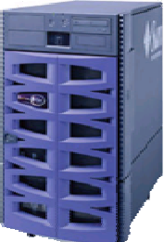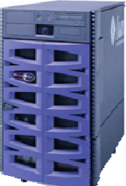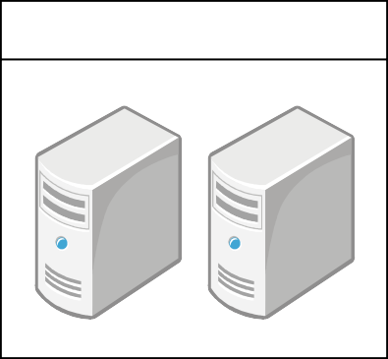Time synchronization is performed using NTP(Network Time Protocol) between the scheduling information distribution system and the plant.
Schedule information distribution system
Power plant
①
Query
②

Response

Figure 5.1 Overview of Time Synchronization

5.2 Time Synchronization Protocol
Describes the client connection method and NTP server settings.

- Client connection method

Table 5.1 Communication Specifications for Time Synchronization

Communications protocols | NTP(Network Time Protocol)
Time synchronization method | Step modes

- NTP server setting

Table 5. 2 NTP Server Settings

NTP server | FQDN | Re-ene.kyuden.co.jp
NTP server | Port | 123

5.3 Time Synchronization Timing
Schedule information delivery systems and power plants are synchronized at the timing shown in Table 5.3.

Table 5.3 Time Synchronization Timing

Synchronization timing | Implementation time zone
Before initial communication ID authentication (including when equipment is replaced) | Optional
When the power supply is started | Optional
Periodic renewal (up to once a day) | ※
Other manual execution (error retry, etc.) | Optional

※ The time zone which can be requested in order to load balance the demand to the schedule information distribution system shall be provided. The time period that can be requested shall be made at the timing of Table 5.4 according to the checksum at the end of the plant ID. If time synchronization fails, retry (up to 5 times) at 1-minute intervals. In the case of another error, the retry is continued after 30 minutes.
Table 5.4 Periodic update timing

Checksum | Implementation time zone
0 | 21:00:00 ～ 21:09:59
1 | 21:30:00 ～ 21:39:59
2 | 22:00:00 ～ 22:09:59
3 | 22:30:00 ～ 22:39:59
4 | 23:00:00 ～ 23:09:59
5 | 23:30:00 ～ 23:39:59
6 | 0:00:00 ～ 0:09:59
7 | 0:30:00 ～ 0:39:59
8 | 1:00:00 ～ 1:09:59
9 | 1:30:00 ～ 1:39:59

